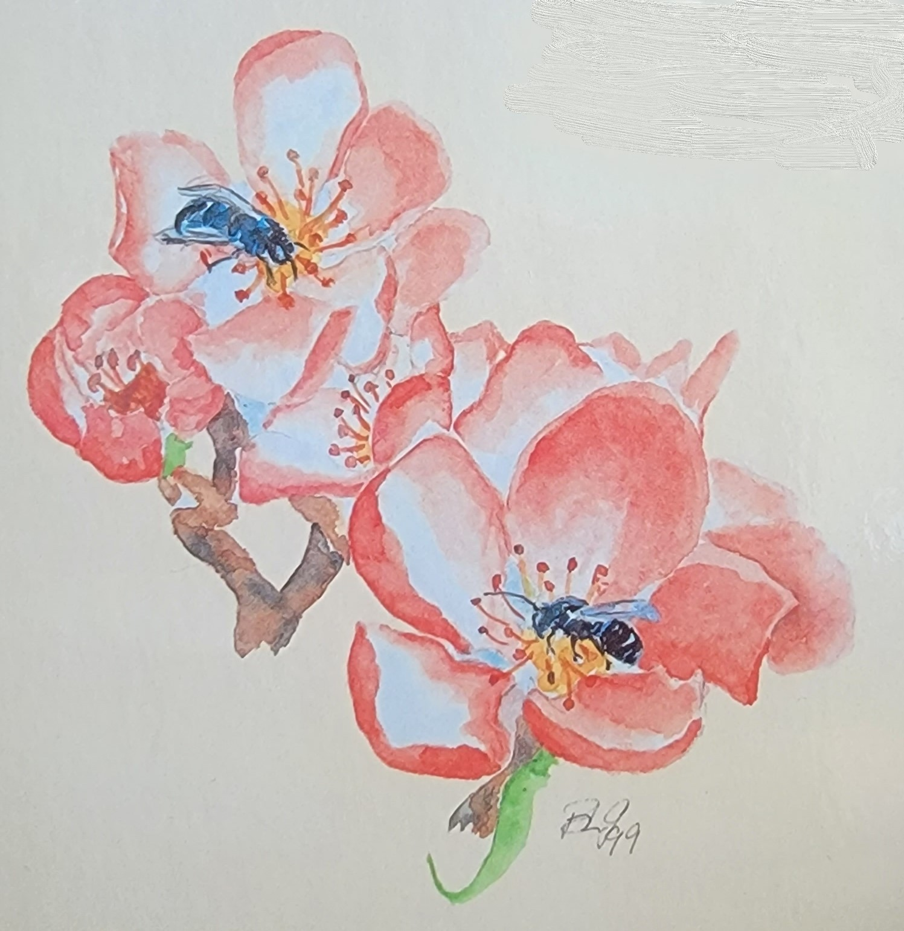

|  | **Orchard Mason Bee Box - 25 Loose Cocoons**  Cocoons have been cleaned, inspected, sorted and have a fully formed Orchard Mason Bee inside. They are ready to be placed in a shelter spring 2024. Cocoons are loose and arrive in a small cardboard box with 9 female and 16 male bees | **Item A01** | **$15** |
| --- | --- | --- | --- |
|  | **The Orchard Mason Bee Book**  Written by the founder of Knox Cellars Orchard Mason Bees, Brian Griffin, first published in 1999. The first edition started an industry. This third edition is the go-to guide for everything you need to know about the Orchard Mason Bee. In an easy to read format it describes the life cycle of the OMB, a native early spring pollinator, and how to host them in backyards and orchards | **Item B01** | **$7.50** |
|  | **Humblebee Bumblebee Book**  Another nature classic by Brian Griffin. This book includes a Field Guide to the North American Bumblebees as well as describing their life history and propagation in the home garden. A truly fascinating read | **Item B02** | **$7.50** |
|  | **Common Bees of Western North America - 6 fold Brochure**  A thick, laminated/waterproof, high-quality 6-fold brochure. Colorful illustrations, informative descriptions, and useful information on diet and habitat for many pollinators, including Orchard Mason Bees, bumblebees of Western North America | **Item B03** | **$7.50** |
|  | **Common Bees of Eastern North America - Brochure**  A thick, laminated/waterproof, high-quality 6-fold brochure. Colorful illustrations, informative descriptions, and useful information on diet and habitat for pollinators of Eastern North America | **Item B04** | **$7.50** |
|  | **100 Plants to Feed the Bees Book**  From The Xerces Society (a non-profit based in Portland, OR) 240 colorful, informative pages. Each plant profile includes which pollinators visit the plant, the quality of honey the nectar produces, when it blooms, how best to use it in the landscape, planting tips, and spectacular photography | **Item B05** | **$10** |
|  | **System 74**  The System 74 consists of a waterproof container filled with 74 each System assemblies (water resistant coated cardboard tube (reusable), white paper liner and reusable black end plug). The System is a favorite of many backyard Orchard Mason Bee hosts for its ease of maintenance. Our System assemblies offer the highest protection for the Orchard Mason Bee from predators and moisture | **Item C01** | **$25** |
|  | **System 200**  A box of 200 System assemblies (water resistant coated cardboard tube (reusable), white paper liner and reusable black end plug). The System is a favorite of Orchard Mason Bee hosts for its ease of maintenance. Our System assemblies offer the highest protection for the Orchard Mason Bee from predators and moisture. Customers have reused the System for many many years, only needing to replace the white paper liner if it was used by the female OMB | **Item C02** | **$49** |
|  | **Liner 130**  The secret to nesting tube success is the replaceable White Paper Liners. In the can are 130 liners ready to provide new, clean nesting chambers each year in the System (water resistant coated cardboard tube (reuseable), white paper liner & reusable black end plug). They can also be inserted into the holes of 48 & 96 Hole Wood Nesting Blocks | **Item C03** | **$13** |
|  | **Liner 400**  Due to ever increasing demand, we offer white paper liners by the case. Our box of 400 liners is just what is needed for a well-established Orchard Mason Bee colony | **Item C04** | **$41** |
|  | **Natural Reed Tubes 50**  This 50 count set of nesting tubes are all natural Phragmites reeds. No paper liners are required, but maybe used if they will fit into the slight variation in diameter of the natural reed. They replicate the natural holes Orchard Mason Bees prefer and are considered single use (if they are occupied during the OMB season) as cocoons can not be removed without splitting them apart | **Item C05** | **$10** |
|  | **Natural Reed Tubes 300**  This 300 count case of Phragmites reeds are what is needed for a busy well established Orchard Mason Bee host location | **Item C06** | **$60** |
|  | **Observation Box – Small**  Hand-crafted Observation Box to hang on the wall so you can see the female OMBs gathering clay, pollen and laying her eggs. This is a great teaching tool for children learning about Orchard Mason Bees | **Item D01** | **$19** |
|  | **ABS Shelter with Systems**  Made of thick ABS plastic piping, built in Washington State and filled with 40 Systems (water resistant coated cardboard tube (reusable), white paper liner and reusable black end plug). A great, very durable, starter house. Orchard Mason bees love how warm the house stays in the spring | **Item D02** | **$16** |
|  | **ABS Shelter with Reeds**  Made of thick ABS plastic piping, built in Washington State and filled with 30 Natural Reeds. A great, very durable, starter house. Orchard Mason bees love how warm the house stays in the spring | **Item D03** | **$16** |
|  | **Wood Shelter with Systems**  Fun starter Orchard Mason Bee shelter we call ‘Mikie’s’ after the designer and builder. Comes ready with 80 Systems (water resistant coated coated cardboard tube (reuseable), white paper liners and reusable black plug) and is built to last with cedar | **Item D04** | **$30** |
|  | **Wood Shelter with Reeds**  Great starter Orchard Mason Bee shelter handmade by a local craftsman that we nicknamed Mikie’s. This one is filled with approximately 70 natural reed tubes. These tubes have slightly varying hole sizes OMB love | **Item D05** | **$30** |
|  | **System 74 Shelter (only)**  Wooden shelter built to hold a System 74, with an attic to release cocoons protected from birds until they emerge. This shelter includes an Observation Box to view the female Orchard Mason Bee working as she builds her clay walls, makes pollen/nectar loaf and egg laying | **Item D07** | **$20** |
|  | **System 74 Shelter with System 74**  This hand-crafted wooden shelter, built in Washington State from locally sourced cedar, includes an Observation Box in the attic (to watch the female OMB as she works) and a System 74 (water resistant coated cardboard tube (reusable), white paper liner & reusable black plug) inside a waterproof/protective container. Triple weather protection! | **Item D08** | **$45** |
|  | **System 74 Double Shelter (only)**  The perfect way to create a stable environment for two System 74s. The all cedar construction is built to last with added protection from the elements | **Item D10** | **$20** |
|  | **48 Hole Wood Nesting Block**  Wood Nesting Block 48 for Orchard Mason Bees makes a great habitat and is designed to be used with or without White Paper Liners. Black End Plugs can be used to block the back of each Wood Nesting Block hole. It comes in two different sizes, 48 and 96 holes (also available on this website). Each section comes apart, making it easy to harvest your cocoons and sanitize the wood block. Making the wood block reusable year-after-year. Recommended location is inside a Shelter 48 | **Item E01** | **$23** |
|  | **48 Wood Shelter (Only)**  Wood Shelter to hold one 48 Hole Wood Nesting Block or nesting material of your choice. This shelter includes an attic space for Orchard Mason Bee cocoons while they await hatching and an Observation Box for viewing the OMB as she works | **Item E02** | **$20** |
|  | **48 Wood Shelter with 48 Hole Nesting Block**  Wood Shelter to hold one 48 Hole Wood Nesting Block. The shelter has an attic to protect the Orchard Mason Bee cocoons from birds until they emerge and an Observation Box to observe the female OMB as she works, collecting clay, pollen/nectar and lays her eggs | **Item E03** | **$43** |
|  | **96 Hole Wood Nesting Block**  This reusable and cleanable habitat is a 96 hole segmented wood block designed to be used with or without White Paper Liners. It comes apart, making it easy to harvest cocoons | **Item E04** | **$30** |
|  | **96 Wood Shelter (Only)**  This Wood Shelter is engineered to hold one 96 Hole Wood Nesting Block (not included). It does include an Observation Box for viewing the Orchard Mason Bee as she works that is stored in a protected attic space to protect OMB cocoons while they are waiting to emerge | **Item E05** | **$30** |
|  | **96 Wood Shelter with 96 Hole Nesting Block**  The best shelter for an existing busy Orchard Mason Bee population or big dreams. This shelter includes a 96 Hole Wood Nesting Block, an attic (that will protect the cocoons from birds while they are emerging) and an Observation Box to inspire that sense of awe we all need in our life, as we watch the female Orchard Mason Bee work. The Wood Nesting Block can be used without or with White Liners | **Item E06** | **$60** |
| Bee Pusher Tool | **System’s Liner Removal Tool**  A tool designed and made by a local craftsman to push the White Paper Liner out of the Cardboard Tube when harvesting cocoons | **Item F01** | **$7** |
| Liner Cutter | **System’s Liner Precut Tool**  The Precut Tool has been engineered and crafted to precut (lengthwise) White Paper Liners prior to inserting into the Cardboard Tubes or Wood Nesting Blocks making it easier to remove cocoons from the White Paper Liner during winter harvesting of cocoons | **Item**  **F02** | **$12** |
|  | **Bee Safe Humidity Box**  Use The Bee Safe Humidity Box for storing your harvested, cleaned & inspected loose cocoons in your refrigerator to maintain proper humidity levels | **Item**  **F03** | **$4** |
| Mason Bee Clay   1 lb. | **Orchard Mason Bee Clay**  Providing clay is helpful when hosting Orchard Mason Bees from 2nd story decks, locations where there is no clay or when you would like to observe them gathering clay | **Item**  **F04** | **$7** |
|  | **Bee Safe Bag - Small**  These bags are critical to storing nesting material securely after the female bee is done flying, until it is time to harvest cocoons and to store next seasons, clean, ready to use, nesting material. The size bag (12" x 14") will fit one 48 hole wood nesting block and over one hundred reeds or Systems | **Item**  **F05** | **$3** |
|  | **Bee Safe Bag - Large**  These bags are critical to storing nesting material securely after the female bee is done flying, until it is time to harvest cocoons and to store next seasons, clean, ready to use, nesting material. The size bag (22.5" x 25") will fit several wood nesting blocks, the 74 Shelter or 48 Shelter and lots of reeds or Systems | **Item**  **F06** | **$5** |
|  | **Complementary informational handouts to copy for customers** | **Item** | **Free** |

* **As a returning purchaser please take note some item numbers have changed, some item**

**names have been updated & there are some new items! Thank you for editing individual purchase order forms**

* **Wholesale Catalog will be updated as needed to disseminate information & be available at** [**https://www.knoxcellarsmasonbees.com/**](https://www.knoxcellarsmasonbees.com/) **, wholesale tab, email for password**
* **To order please email the completed Knox Cellars Orchard Mason Bee order form to**

**knoxcellarsmasonbees@gmail.com with your desired items, shipping & your requested shipping date. There will be an invoice with the shipment & emailed when items ship**

* **We Ship USPS Priority for smaller Orders & UPS or FedEx for larger Orders**

**Shipping charges apply**

**Thank you!**

**~ We appreciate your business ~**